SURE TRUST
G5-CYBERSECURITY AND ETHICAL HACKING
XSS PROJECT

BY-SUFIYA HAFIZ
UNDER THE GUIDANCE: HIMANEESH SIR

ACKNOWLEDGEMENT

I extend my heartfelt gratitude to Radhakumari ma’am for providing me with the opportunity to undertake my internship at SURE TRUST, her leadership and commitment to fostering professional development have been instrumental in shaping my experience.

I would also like to express my sincere thanks to my guide Himaneesh sir, for his unwavering support and guidance throughout the internship, his expertise, mentorship and constructive feedback significantly contributed to my growth in this course. I am truly grateful for the invaluable experiences and knowledge gained under both Radhakumari ma’am and Himaneesh sir. This internship has been a transformative journey, and I look forward to applying the skills acquired in my future endeavors.

INTRODUCTION

Embarking on the XSS game challenge internship has been an enriching journey into the intricate realm of web security. This encapsulates my experiences, discoveries, and insights gained throughout the internship period, delving into the nuances of identifying and mitigating Cross-Site Scripting (XSS) vulnerabilities.
The XSS game challenge provided a dynamic platform for each level serving as a unique puzzle to unravel. From the initial levels, where foundational knowledge was tested, to the more advanced stages, demanding creative problem solving, the internship offered a holistic learning experience in the realm of web security.
This serves as a testament to the practical skills acquired during this internship and the continuous pursuit of knowledge in the ever-evolving landscape of cybersecurity.

INDEX

- To execute the alert() function in JavaScript
- Timer
- Gallery
- Google Reader
- Angular

XSS GAME CHALLENGE

LEVEL 1
<script>alert(1)</script>
Mission Objective: Inject a script to popup a javascript alert() in the frame. Now type <script>alert(1)</script> and you will see that there is no encoding happening and the popup gets triggered.

LEVEL 2
3’**alert());//
Mission Objective: The value we passed by the index page is straightly added into the function parameter at the timer. The Javascript will try to evaluate 3**alert() before it calls the start timer function. To evaluate the result of 3**alert() it needs to get the value returned by the function alert(), which will make the browser execute the alert function.

LEVEL 3
#1’onerror=alert();>’
Mission Objective: The page will try to load the image from the source ‘1’ which will fail miserably and then trigger the onerror attribute’s code.

LEVEL 4
confirm?next=javascript:alert(1)
Mission Objective: The confirm page also accepts the next parameter and uses it to redirect the user to its given value. After the time runs out, it will be redirected to the link that will be understood by the browser as a bookmarklet, executing the code.

LEVEL 5

?utm_term={{alert()}}
Mission Objective: In this we modify the url which was given, in the url write the onerror function to generate the alert message.
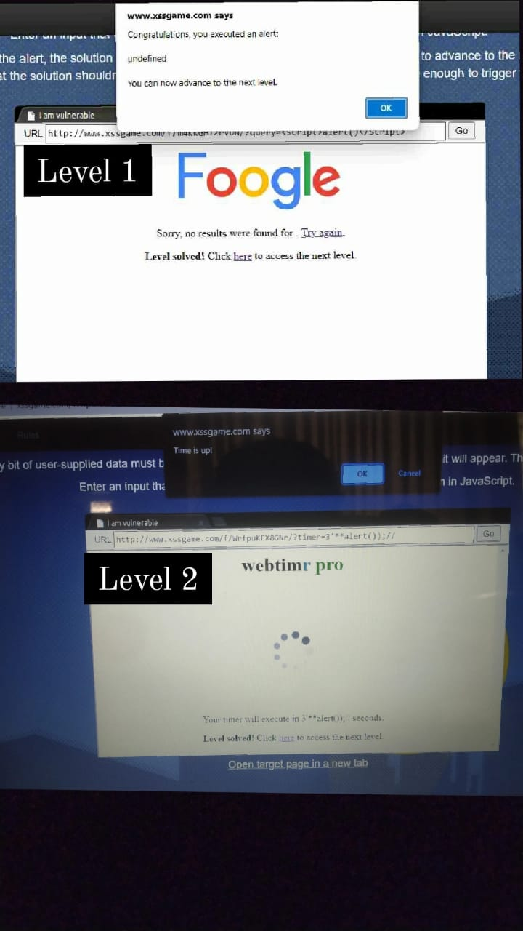

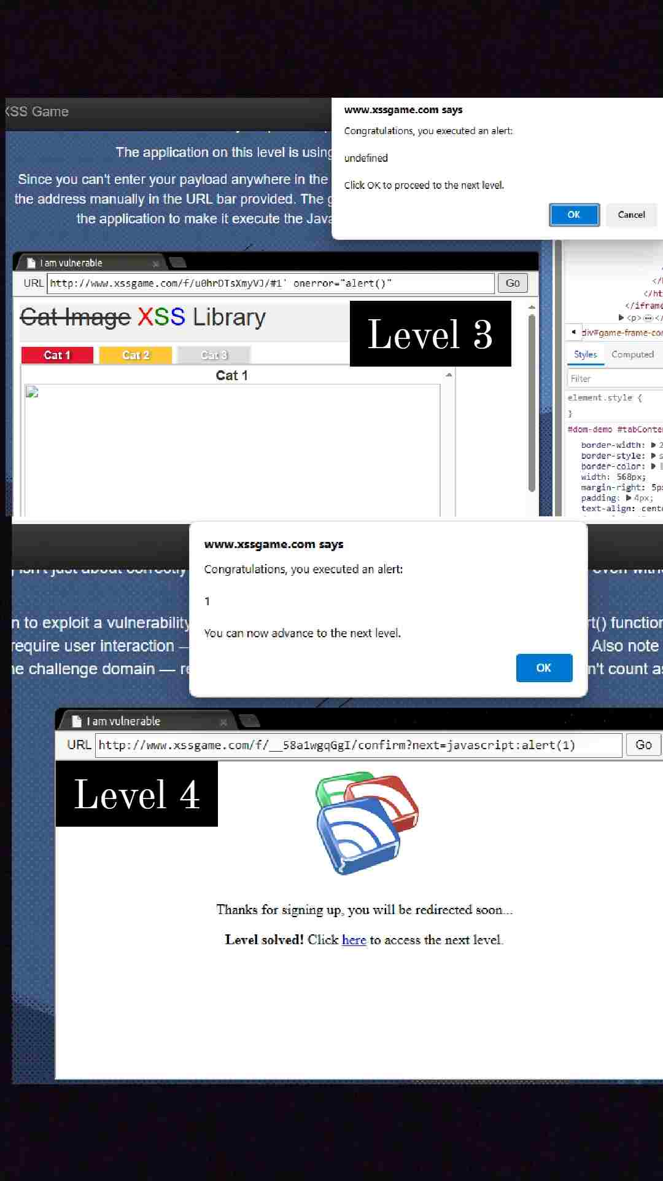
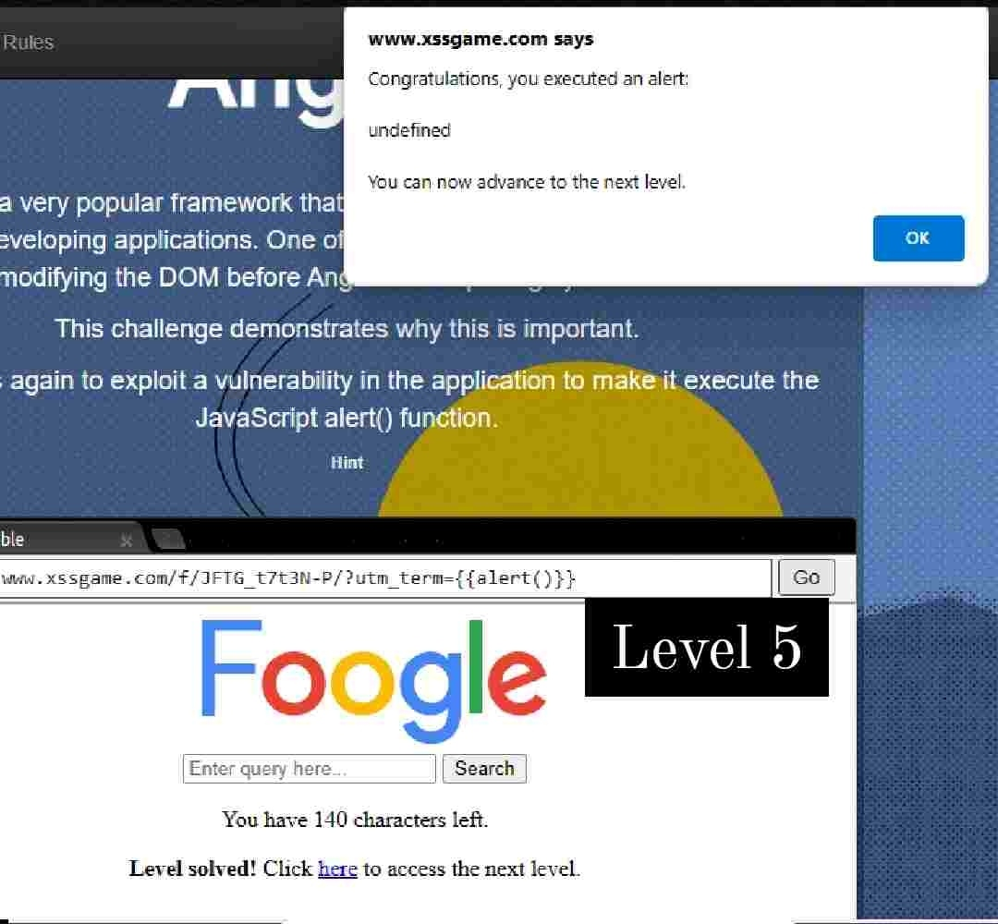

CONCLUSION

In conclusion, this Cybersecurity course internship has not only enhanced my technical competencies but has also fostered a deeper appreciation for the importance of cybersecurity in our interconnected world. As I move forward, I carry with me the knowledge, experiences, and a heightened sense of responsibility to contribute effectively to the ongoing efforts in securing digital landscapes. This internship has been a stepping stone in my cybersecurity journey, and I look forward to applying the skills acquired to contribute meaningfully to the ever-evolving field of cybersecurity.

